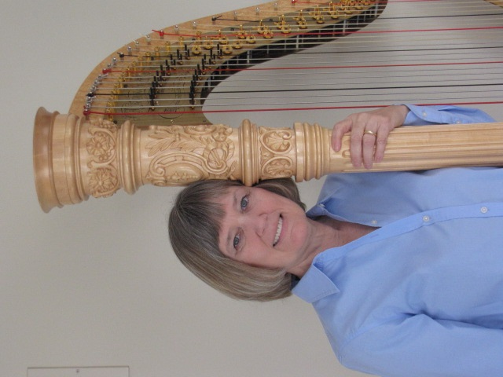
3M Concert
Sunday, February 14, 2016
2:00—3:30 pm
Come hear Renowned Harpist
Deborah Wells Clark
Freewill donations accepted
Reception following

Deborah Wells Clark is the Principal Harpist with the Kansas City Symphony. Deborah has performed throughout the
United States, Europe and Singapore. Clark holds the Doctor of Musical Arts degree from the University of Missouri at Kansas City. When not performing or teaching, Deborah enjoys traveling and flying single engine aircraft.

