Have you ever wondered what that building is at the corner
of 26th & Ridge???

At Sanctuary of Hope, find the calm in the storm.
ENJOY, EXPLORE, AND ENCOUNTER HOPE

HOPEfest

Come experience your neighborhood prayer & retreat center:
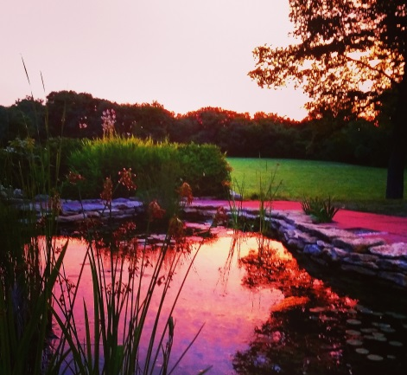
Join us Saturday, JUNE 11th
11 AM– 2 PM
2601 Ridge Ave, KCK 66102
call for info: 931-321-4673

FREE ADMISSION!

ENJOY: LIVE Music, FREE Food, Photo Contest (judging @ 1:30 PM)
& Display, Balloon Sculptures (12:30-1:30 PM), Art for All Ages, Piñata (@ 1:30 PM), and Games
EXPLORE: Tour our Gardens, Nature Trails, Labyrinth and Retreat Facilities
ENCOUNTER: Meet our Staff, Associates, Volunteers, Partners,
& Neighbors

Partners in HOPE: Avenue of Life and Youth Volunteer Corps
